- \Operation\Gluing\Gluing, pneumatic pressing tool
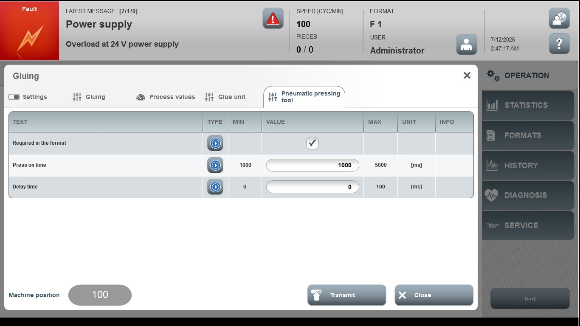
Acceptance criterion | Limits | Pass / Fail: Dev-No. | Date | Initials
Screen matches screenshot | N / A
Delay time for closing pneumatic pressing tool | 0 … 100
Pressing time | 1000 … 5000

